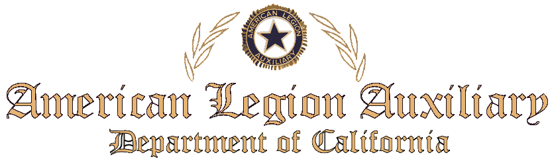

In Honor of Over fifty years
of Service to our Veterans

Presented to _________________________

Thank you for your commitment to enhance the lives of our veterans, military, and their families, both at home and abroad

On this day of ______________

